**Lab 03**

**INTRODUCTION TO XILINX ISE, Spartan 6 BOARD AND IMPLEMENTATION OF RIPPLE CARRY ADDER AND FULL SUBTRACTOR**



**Spring 2025**

Submitted by: **Mohsin Sajjad**

Registration No: **22pwsce2149**

Class Section: **A**

“On my honor, as student of University of Engineering and Technology, I have neither given nor received unauthorized assistance on this academic work.”



Student Signature: ______________

Submitted to:

**Engr. Faheem Jan**

Month Day, Year (16 02, 2025)

Department of Computer Systems Engineering

University of Engineering and Technology, Peshawar

**Objectives:**

* Introduction to FPGA
* Introuction Xilinx ISE

LAB TASKS:

1-Implement buffer ON the Kit and attach the snapshot.

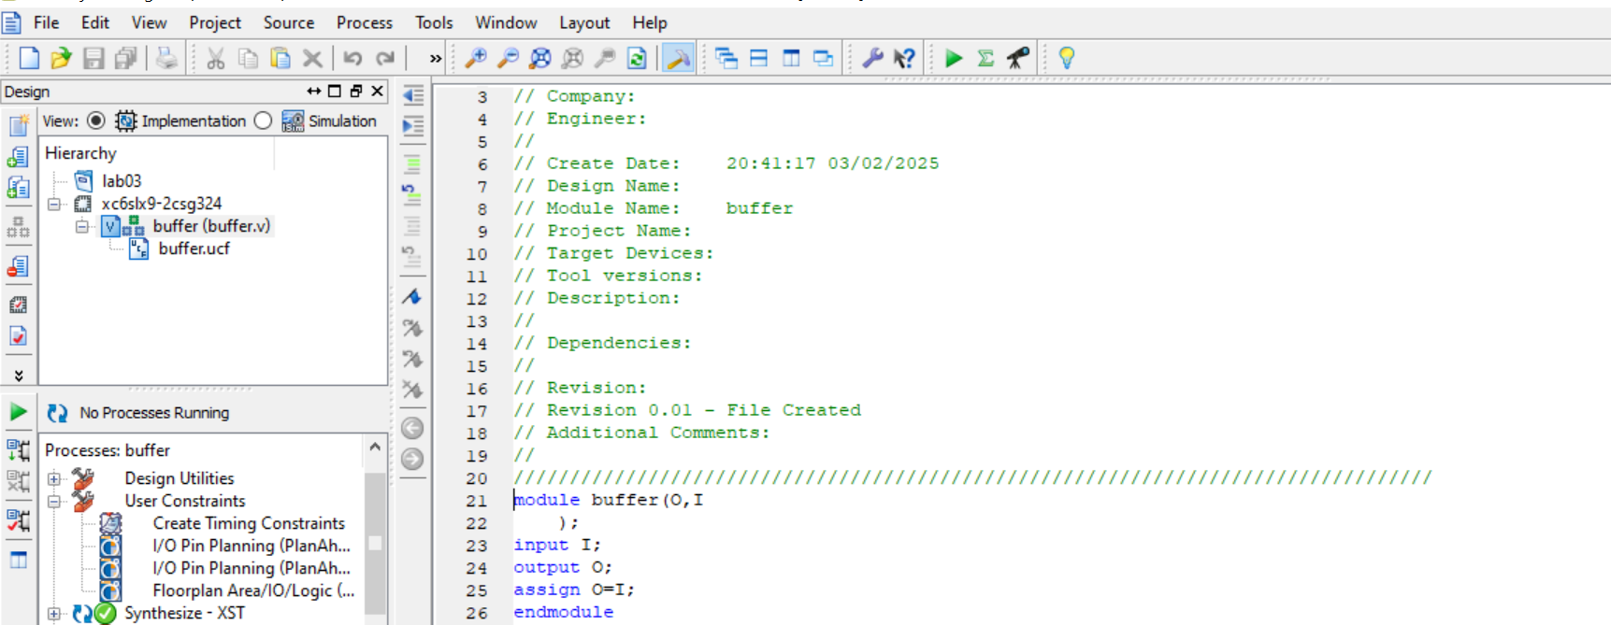

**Output on Xilinx:**

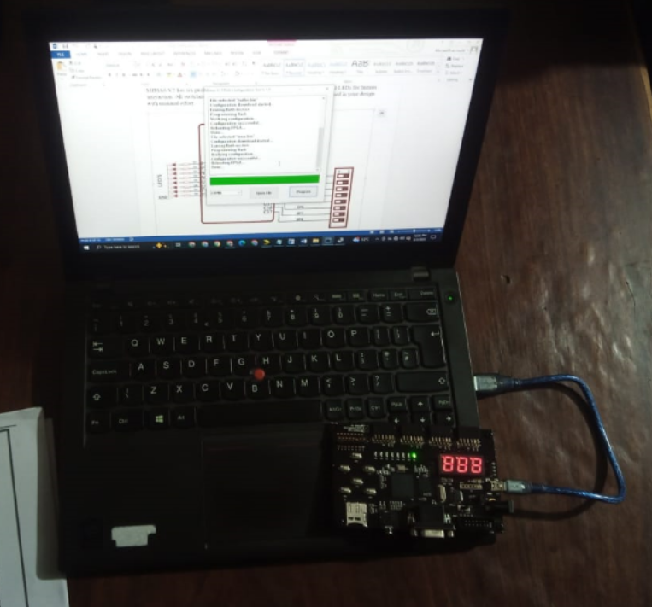

2-Implement AND/OR/XOR gate on the Kit and attach the snapshot.

**And Gate:**

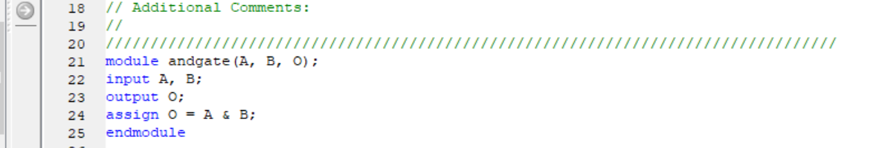

**Output:**

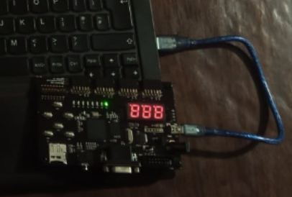

**OR Gate:**

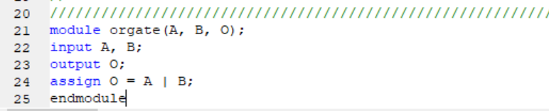

**Output:**



**XOR Gate:**

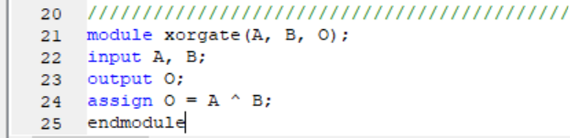

**Output:**



**3-Impement OR gate using NAND gate**

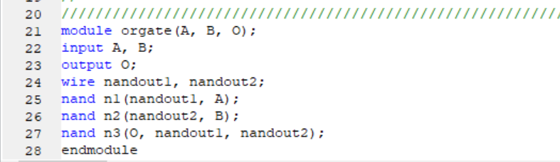

**Output Xilinx:**

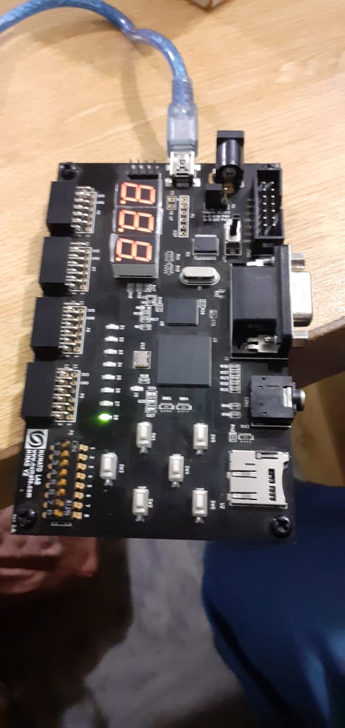

**4- Implement Lab1 and Lab1 ON the Kit and attach snapshot.**

**Equation:**

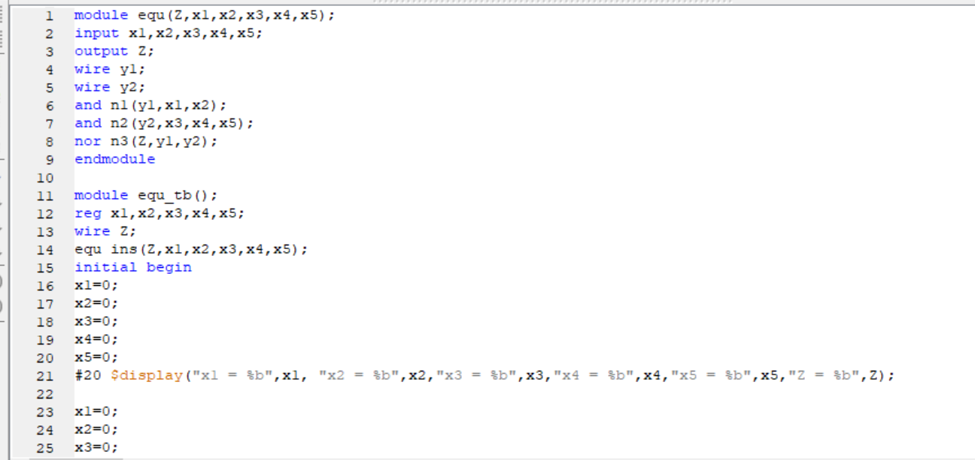

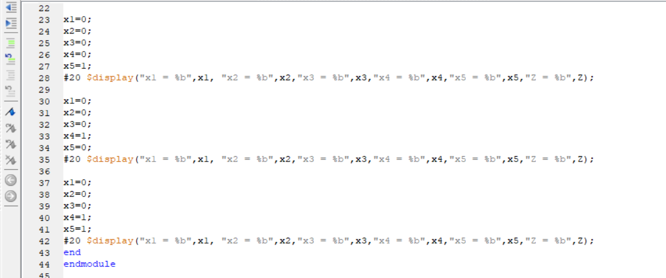

**Xilinx output:**

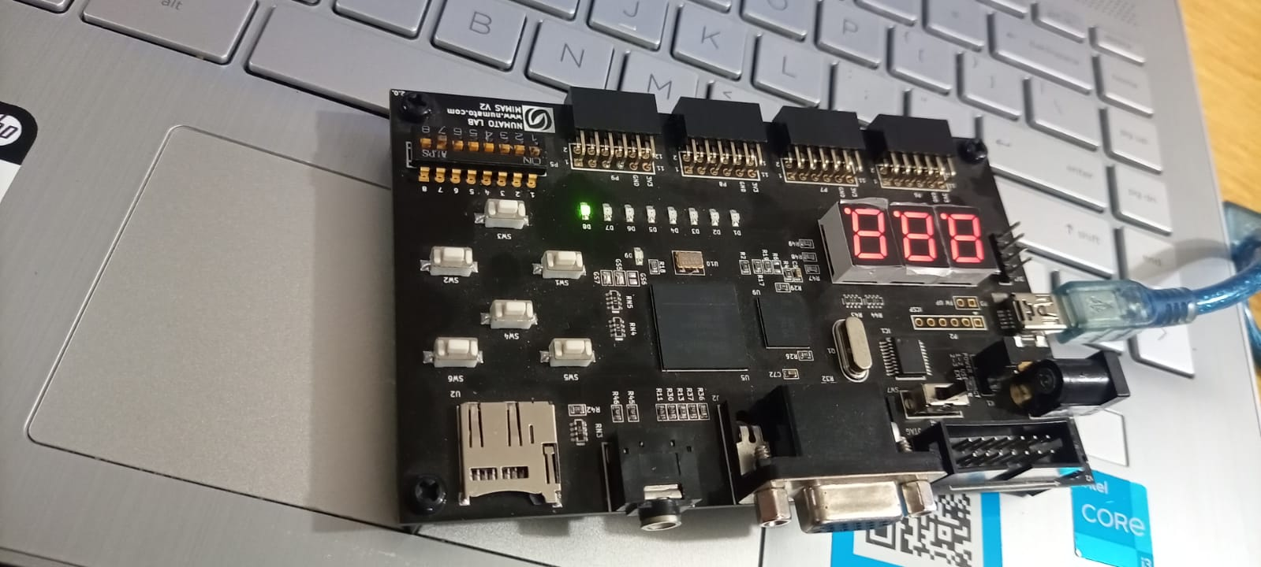

**Logic Circuit:**

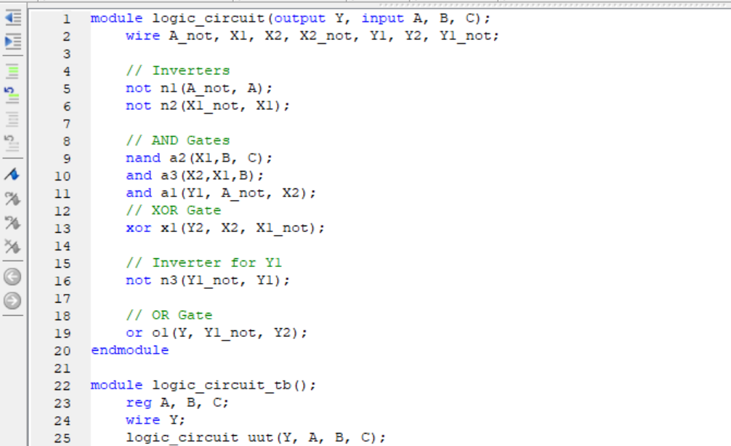

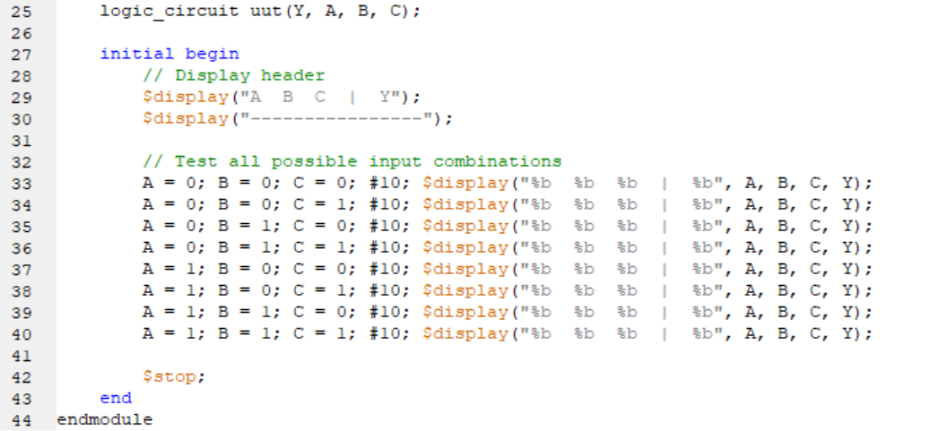

**Xilinx Output:**

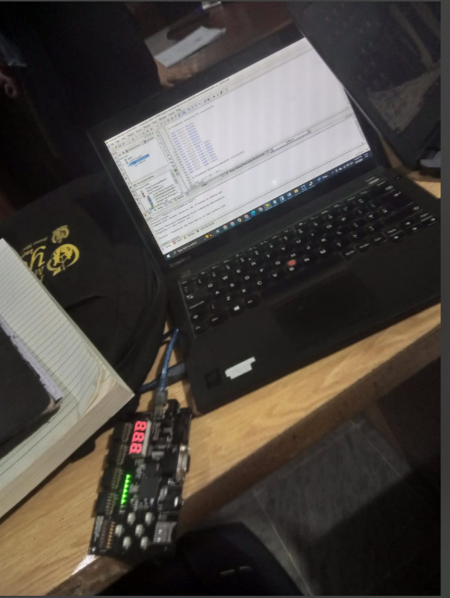

**Ripple Carry Adder:**

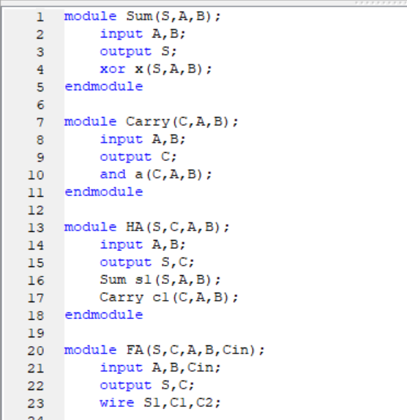

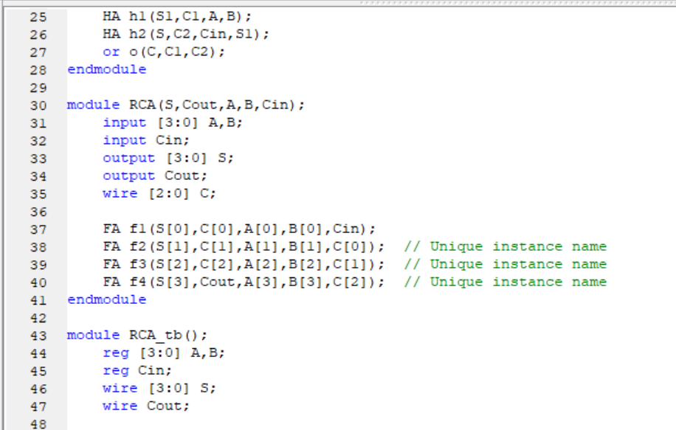

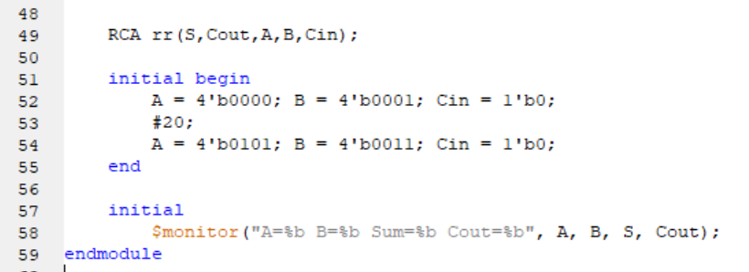



**5- Implement Full Subtractor on the board and verify the truth table**

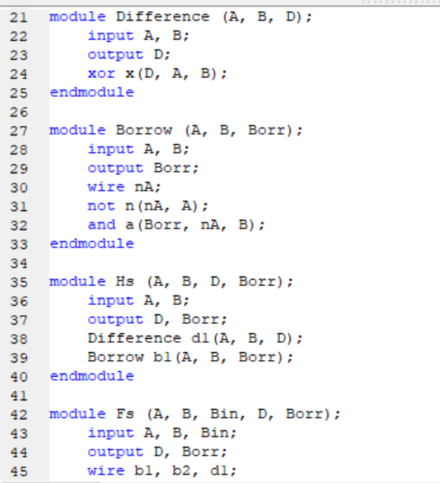

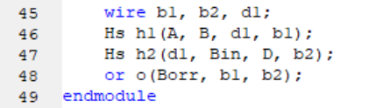

**Output Xilinx:**

